ANNAMACHARYA INSTITUTE OF TECHNOLOGY AND SCIENCES
Tirupati, Andhra Pradesh
Department of Electronics and Communication Engineering

MINI PROJECT REPORT
on
TODO APP IN DJANGO
Task Management web application

Submitted by
K. Ravi Teja (24AK5A0428)
P. Mani Kumar (24AK5A0417)
G. P. Ravi Teja (24AK5A0427)

Table of Contents
Table of Contents 1
1. Introduction 1
1.1 Objective 1
1.2 Scope 1
2. Problem Statement 1
3. Methodology / Approach 1
3.1 Development Process 1
3.2 System Architecture 1
3.3 Technology Stack 1
4. System Design 1
4.1 Database Models 1
4.2 Application Routes 1
5. Screenshots / Application Demo 1
5.1 Login Page 1
5.2 Registration Page 1
5.3 Dashboard — Task List 1
5.4 Add Task Form 1
5.5 Dashboard — Multiple Tasks 1
5.6 Task Completion 1
6. Results / Outcome 1
7. Conclusion 1
7.1 Future Enhancements 1
8. References 1

1. Introduction
TaskFlow is a multi-user Todo Management web application developed using Django, a high-level Python web framework. The application allows users to securely register, log in, and manage their personal tasks with rich organizational features including priority levels, custom categories, and due dates.
This project was developed as part of the CRT 2027 Batch Mini Project requirement to demonstrate practical, full-stack Python web development skills using the Model-View-Template (MVT) architecture.

1.1 Objective
- To design and develop a secure, multi-user web-based task management system.
- To implement full CRUD (Create, Read, Update, Delete) functionality for task management.
- To apply Django's authentication system for user registration and login.
- To build an intuitive, responsive user interface using Bootstrap 5.
- To gain hands-on experience with relational database design and ORM-based queries.

1.2 Scope
The application is designed for individual users who want to organize personal or professional tasks. Each registered user has a private workspace; tasks and categories created by one user are not visible to others. The system supports task prioritization, categorization, deadline tracking, and filtering/search capabilities.

2. Problem Statement
Manually tracking daily tasks using paper notes, sticky notes, or generic note-taking applications is inefficient, disorganized, and prone to errors. Most basic to-do list applications lack personalization features such as priority tagging, category-based organization, or deadline tracking, making it difficult for users to manage tasks effectively as their workload grows.
Additionally, simple todo applications often do not support multiple users or secure, private data storage, which limits their usefulness in real-world, multi-user environments.
There is a need for a web-based, secure, and feature-rich task management system that allows users to:
- Create an account and securely log in to access only their own tasks.
- Organize tasks using custom, color-coded categories.
- Assign priority levels (High, Medium, Low) to tasks.
- Set due dates and receive visual indication of overdue tasks.
- Search and filter tasks based on status, priority, or category.

3. Methodology / Approach
The project was developed following Django's Model-View-Template (MVT) architectural pattern, which separates data handling, business logic, and presentation layers for maintainability and scalability.

3.1 Development Process
- Requirement Analysis: Identified core features required for a premium todo application (auth, categories, priority, due dates, filters).
- Database Design: Designed two primary models — Todo and Category — linked to Django's built-in User model through Foreign Key relationships.
- Authentication: Implemented user registration, login, and logout using Django's built-in authentication framework, ensuring each user can only access their own data.
- Backend Development: Built Django views to handle CRUD operations for tasks and categories, using Django Mode lForms for validation.
- Filtering & Search: Implemented dynamic QuerySet-based filtering by task status, priority, category, and keyword search.
- Frontend Development: Designed a responsive, modern user interface using HTML5, custom CSS, and Bootstrap 5, including a dashboard with live task statistics.
- Testing: Verified all core workflows — registration, login, task creation, editing, filtering, completion toggling, and deletion — through manual and automated testing.

3.2 System Architecture
The application follows Django's MVT pattern:
- Model: Defines the data structure (Todo, Category) and their relationships with the User model, stored in an SQLite database.
- View: Contains the business logic that processes requests, interacts with models, and determines the appropriate response.
- Template: Renders the HTML pages dynamically using Django's template engine, styled with Bootstrap 5 and custom CSS.

3.3 Technology Stack
Layer | Technology Used
Backend | Python, Django 6.0
Frontend | HTML5, CSS3, Bootstrap 5
Database | SQLite (Django ORM)
Authentication | Django built-in auth system
Version Control | Git & GitHub

4. System Design

4.1 Database Models
Category Model: Stores user-defined categories with a name and a hex color code, linked to the User model via ForeignKey (one user can have many categories).
Todo Model: Stores task details including title, description, category (ForeignKey, optional), priority (High/Medium/Low), due date, completion status, and timestamps. Each task is linked to the User who created it.

4.2 Application Routes
URL | Description
/register/ | Create a new user account
/login/ | User login
/logout/ | User logout
/ | Dashboard — list, search, and filter tasks
/add/ | Add a new task
/edit/<id>/ | Edit an existing task
/delete/<id>/ | Delete a task
/toggle/<id>/ | Mark a task complete or incomplete
/categories/ | Manage categories
/admin/ | Django admin panel

5. Screenshots / Application Demo
The following screenshots demonstrate the working TaskFlow application, captured from a live local deployment, covering authentication, task creation, and task completion workflows.

5.1 Login Page
Users securely log in with their registered username and password.
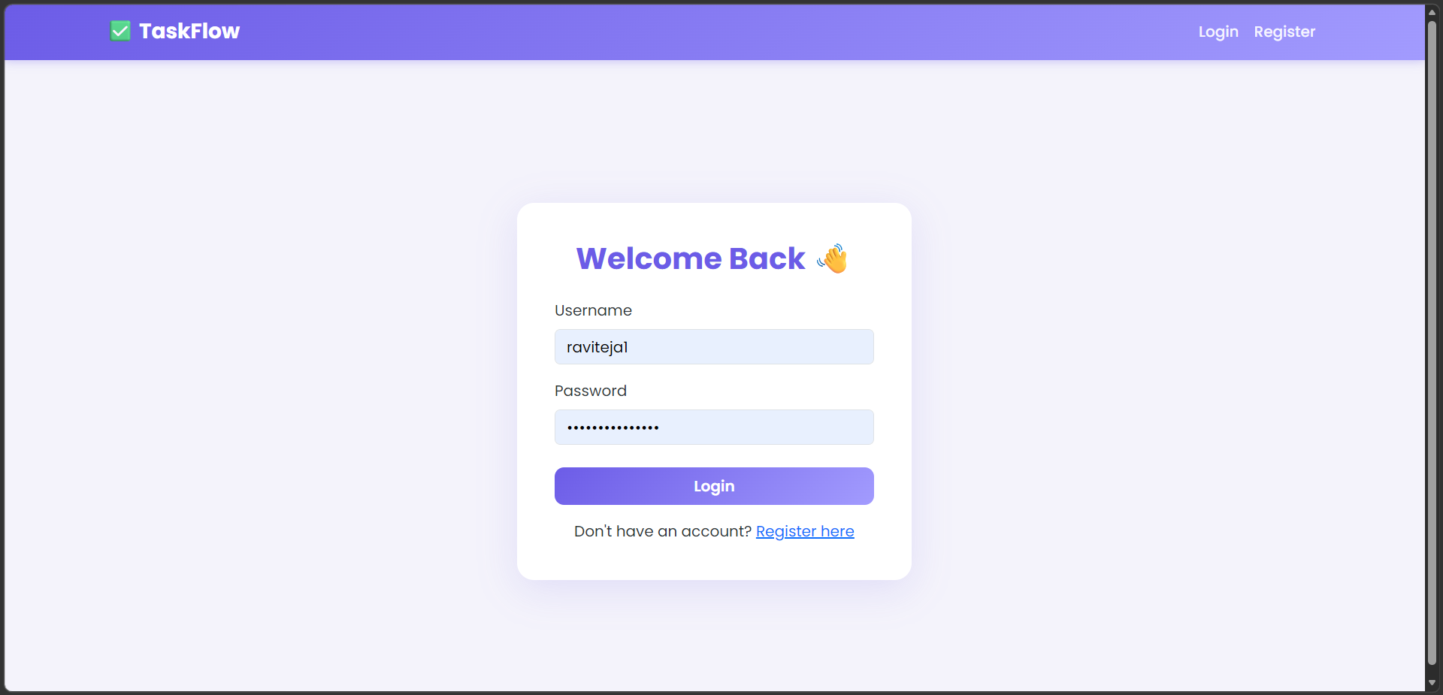

5.2 Registration Page
New users can create an account by providing a username, email, and password.
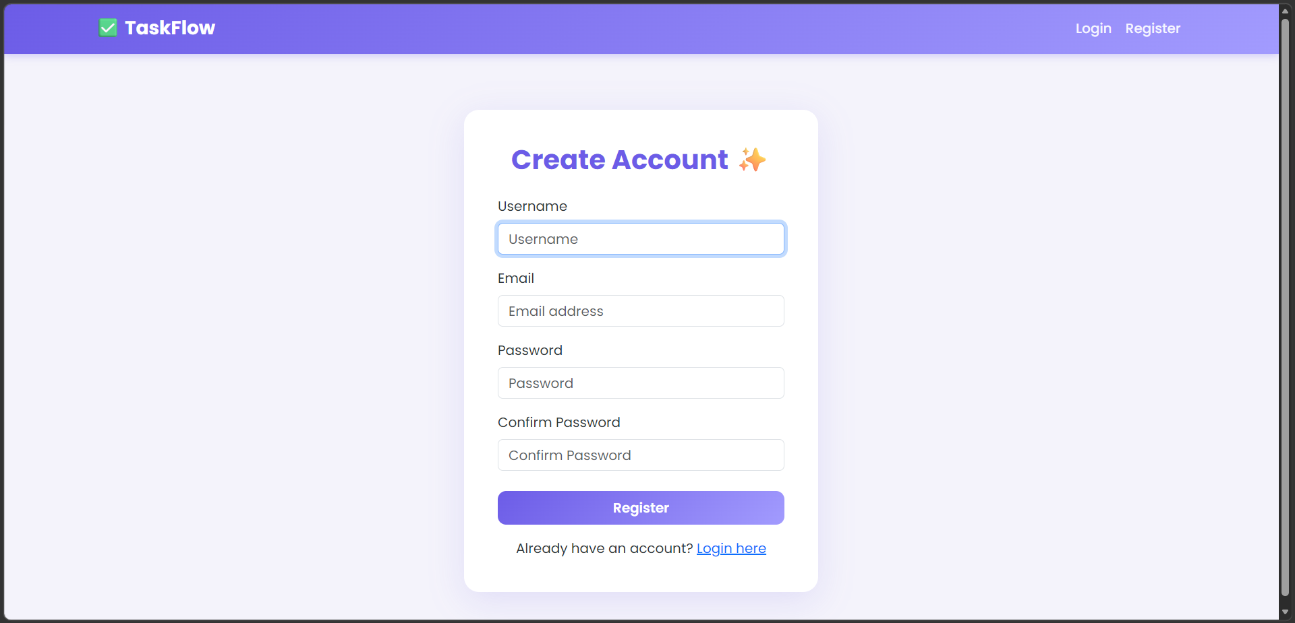

5.3 Dashboard — Task List
The main dashboard displays task statistics (Total, Pending, Completed) along with search and filter options.
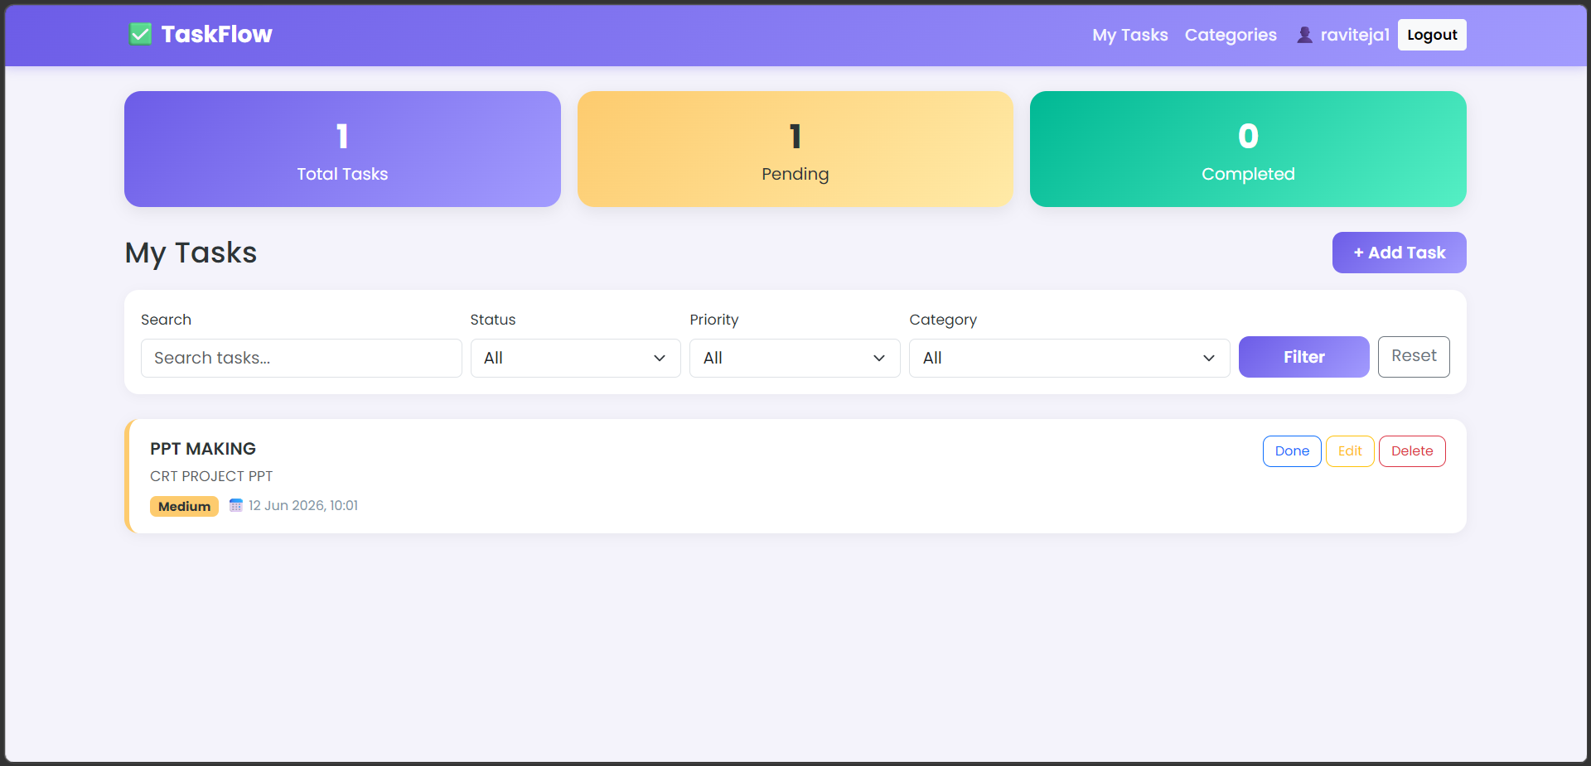

5.4 Add Task Form
Users can create a new task with a title, description, category, priority, and due date.
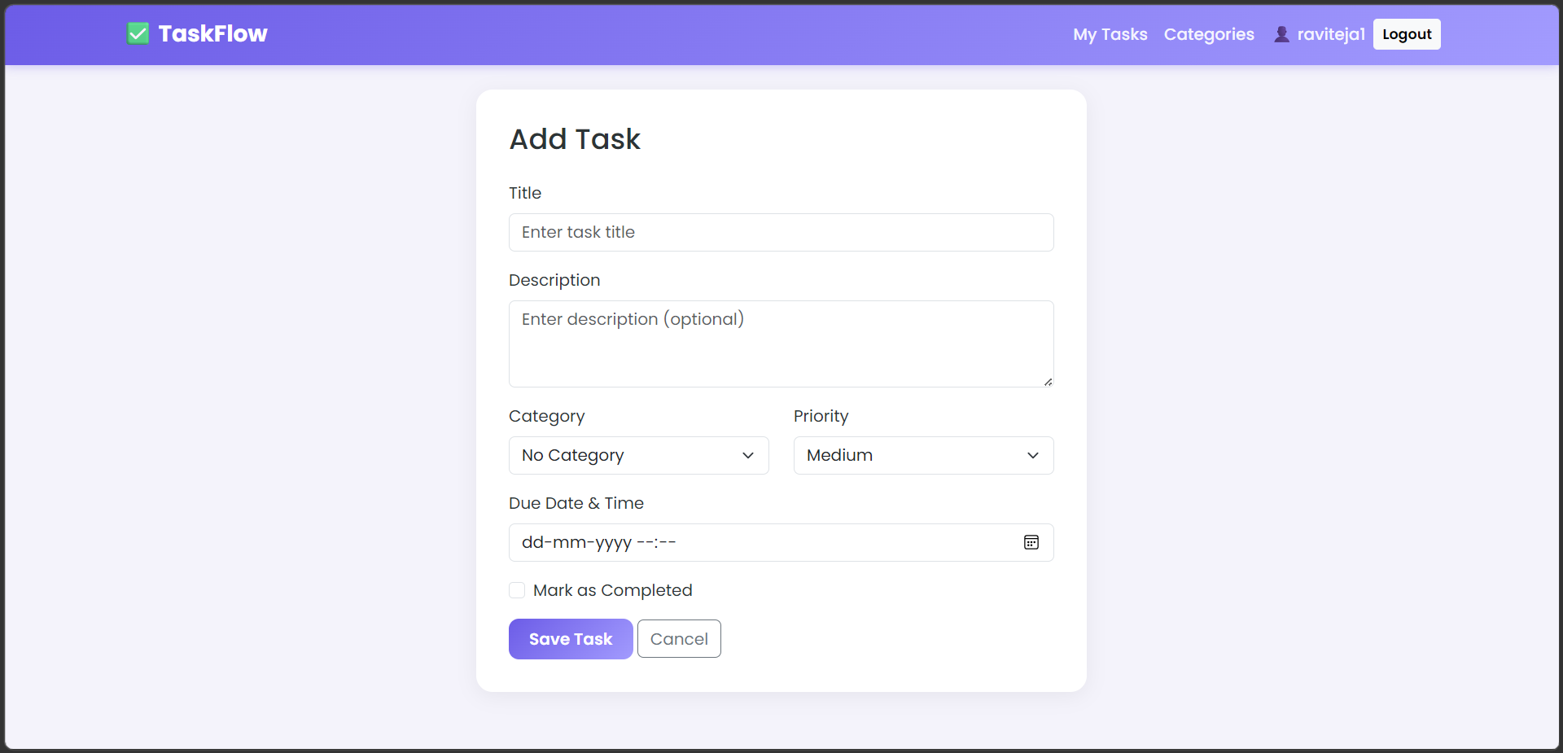

5.5 Dashboard — Multiple Tasks
The dashboard updates in real time as new tasks are added, reflecting accurate task counts.
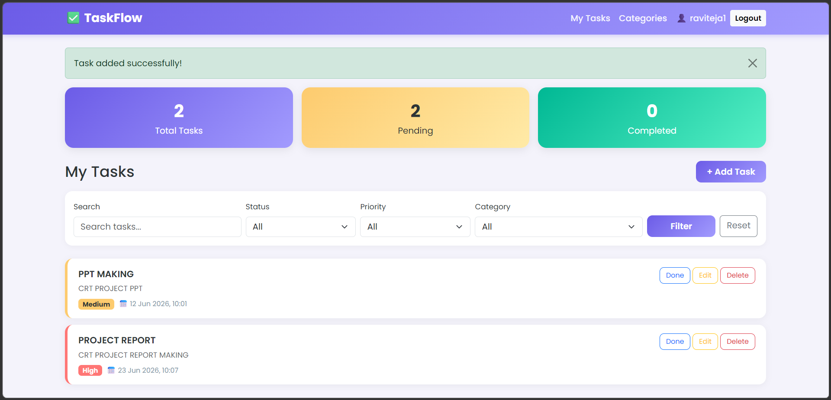

5.6 Task Completion
Completed tasks are visually struck through and marked with a green “Completed” badge.
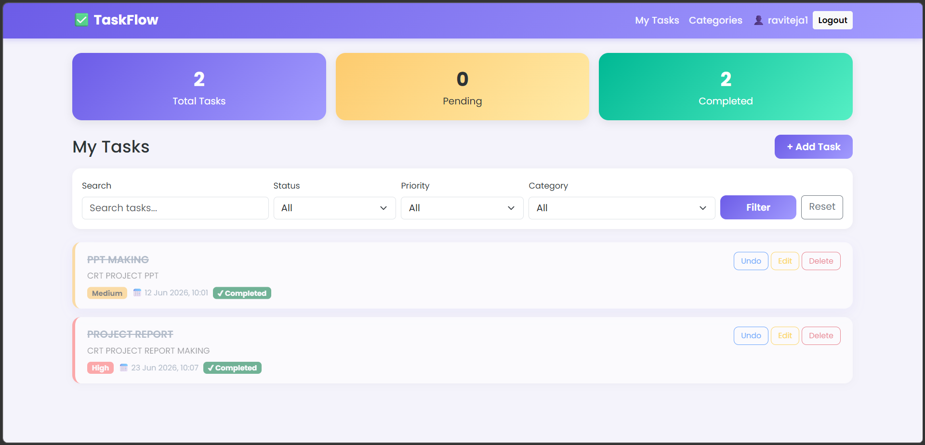

6. Results / Outcome
The completed TaskFlow application successfully implements all planned features, resulting in a fully functional, multi-user todo management system. Key outcomes include:
- Secure user registration, login, and logout, with each user's data kept private.
- Full CRUD functionality for tasks — users can add, view, edit, complete/undo, and delete tasks.
- Custom, color-coded categories allowing users to organize tasks (e.g., Work, Personal, Study).
- Priority tagging (High, Medium, Low) with color-coded visual indicators.
- Due date and time tracking, with automatic detection and highlighting of overdue tasks.
- Dynamic search and multi-criteria filtering (status, priority, category).
- A live dashboard displaying total, pending, and completed task counts.
- A responsive, modern user interface built with Bootstrap 5 and a custom purple-gradient theme.
The application was tested across all core user workflows — registration, login, task and category management, filtering, and logout — and performed as expected without errors.

7. Conclusion
The TaskFlow project successfully demonstrates the development of a complete full-stack Python web application using Django's MVT architecture. Through this project, practical experience was gained in relational database design using ForeignKey relationships, user authentication and session management, form handling and validation, and responsive frontend design.
This project reflects the core competencies expected of a full-stack Python developer and provides a strong foundation for building more advanced, production-ready web applications in the future.

7.1 Future Enhancements
- Email/SMS reminders for upcoming or overdue tasks.
- Drag-and-drop task reordering and Kanban-style board view.
- Dark mode toggle for improved accessibility.
- REST API development for mobile application integration.
- Task sharing and collaboration features between users.

8. References
- Django Official Documentation — https://docs.djangoproject.com/
- Bootstrap 5 Documentation — https://getbootstrap.com/docs/5.3/
- Python Official Documentation — https://docs.python.org/3/
- Project Source Code Repository — GitHub (link submitted via Google Form)

